Example: Types attribute in Global classes
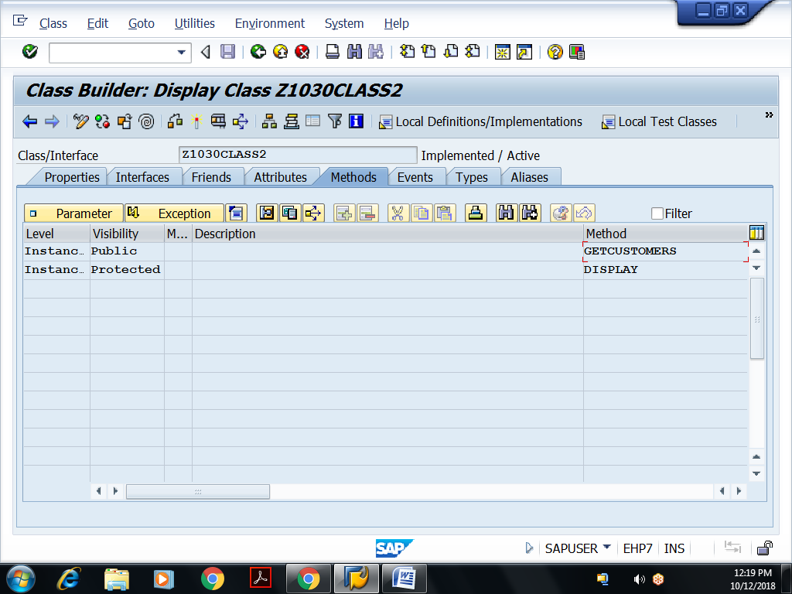
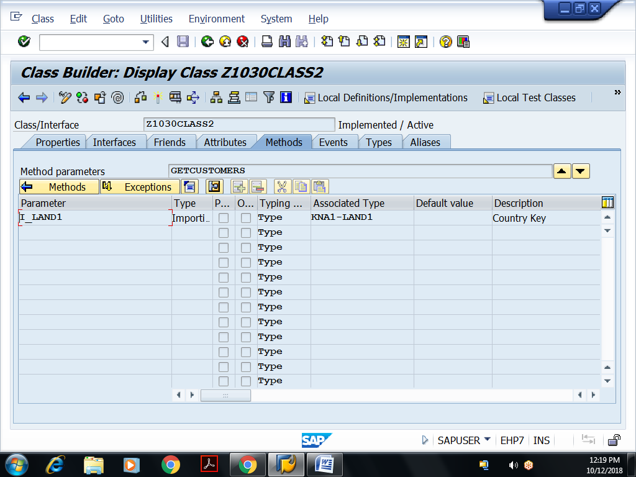
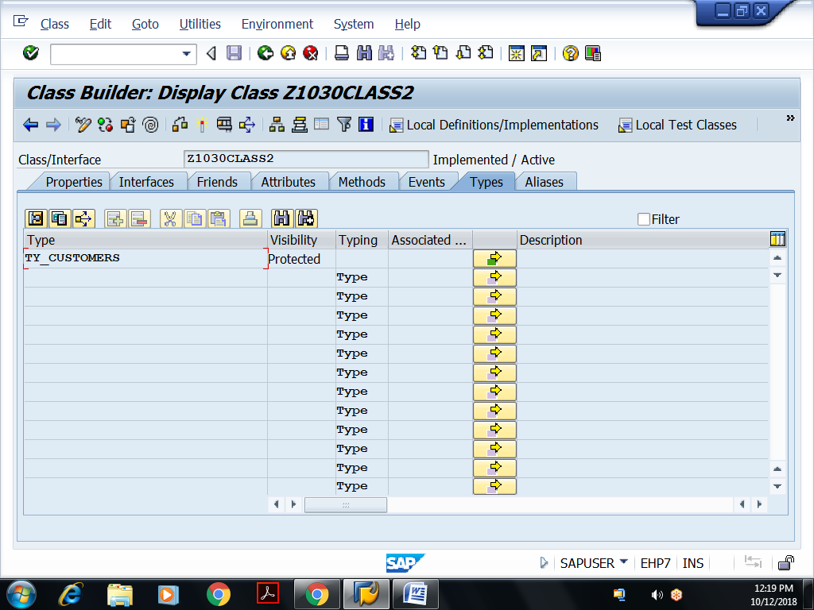
Click on Direct type entry, opens editor, declare the following
types : begin of TY_CUSTOMERS,
kunnr type kna1-kunnr,
name1 type kna1-name1,
ort01 type kna1-ort01,
end of ty_customers.
data t_customers type table of ty_customers.
Implementation of Methods:
method GETCUSTOMERS.
select kunnr name1 ort01
from kna1
into table t_customers
where land1 = i_land1.
if sy-subrc eq 0.
write :/ 'No of Customers :',sy-dbcnt.
call method display.
else.
message 'No customers' type 'I'.
endif.
endmethod.
method DISPLAY.
data wa_customer type ty_customers.
format color 3.
loop at t_customers into wa_customer.
write :/ wa_customer-kunnr,
wa_customer-name1,
wa_customer-ort01.
endloop.
format color off.
endmethod.
Executable program: Accessing above global class components
REPORT Z1030OOPS8.
data ob type ref to z1030class2.
CREATE OBJECT OB.
PARAMETERS p_land1 type kna1-land1.
CALL METHOD OB->GETCUSTOMERS
EXPORTING
I_LAND1 = p_land1.
Example: Local Friend classes
REPORT Z1030OOPS9.
class lcl_pqr DEFINITION deferred. "definition delayed
class lcl_mnr DEFINITION deferred.
class lcl_abc DEFINITION FRIENDS lcl_pqr lcl_mnr z1030class2.
public SECTION.
methods m1.
PROTECTED SECTION.
methods m2.
PRIVATE SECTION.
methods m3.
endclass.
class lcl_abc IMPLEMENTATION.
method m1.
write :/ 'Inside Instance public method m1 of abc class...'.
ENDMETHOD.
method m2.
write :/ 'Inside Instance protected method m2 of abc class...'.
ENDMETHOD.
method m3.
write :/ 'Inside Instance private method m3 of abc class...'.
ENDMETHOD.
endclass.
class lcl_pqr DEFINITION.
public SECTION.
methods m4.
endclass.
class lcl_pqr IMPLEMENTATION.
method m4.
write :/ 'Inside Instance public method m4 of pqr class...'.
data k type ref to lcl_abc.
create object k.
call method k->m1.
call method k->m2.
call method k->m3.
endmethod.
endclass.
class lcl_mnr DEFINITION.
public SECTION.
methods m5.
endclass.
class lcl_mnr IMPLEMENTATION.
method m5.
data k type ref to lcl_abc.
create object k.
call method : k->m1,
k->m2,
k->m3.
endmethod.
endclass.
START-OF-SELECTION.
data ob type ref to lcl_pqr.
create object ob.
call method ob->m4.

Example: Global Friend classes
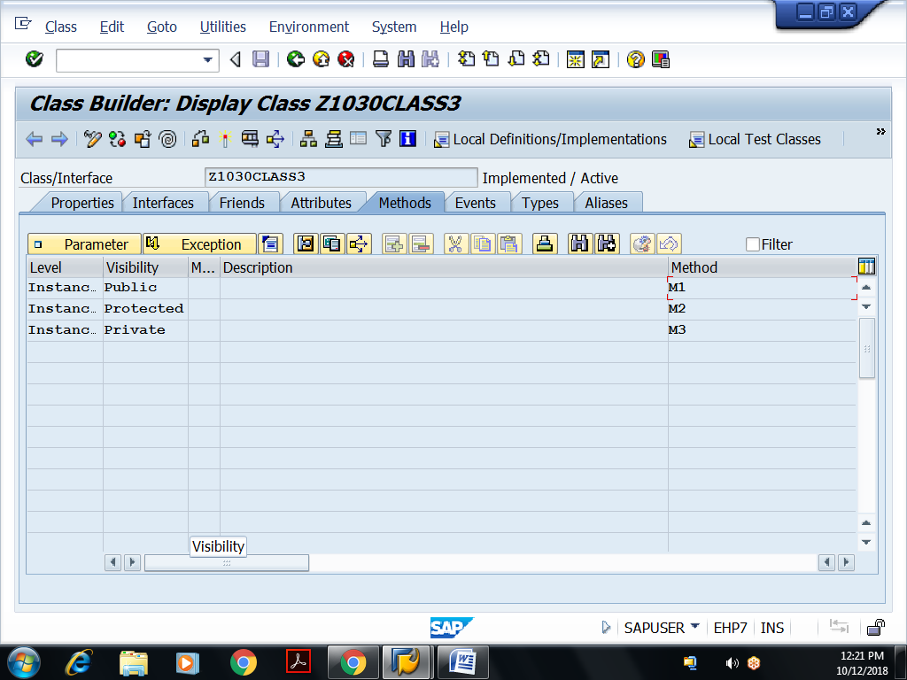
Implementations of methods:
method M1.
write :/ 'Inside instance public method m1 of class3...'.
endmethod.
method M2.
write :/ 'Inside instance protected method m2 of class3...'.
endmethod.
method M3.
write :/ 'Inside instance private method m3 of class3...'.
endmethod.
Save, activate the global class
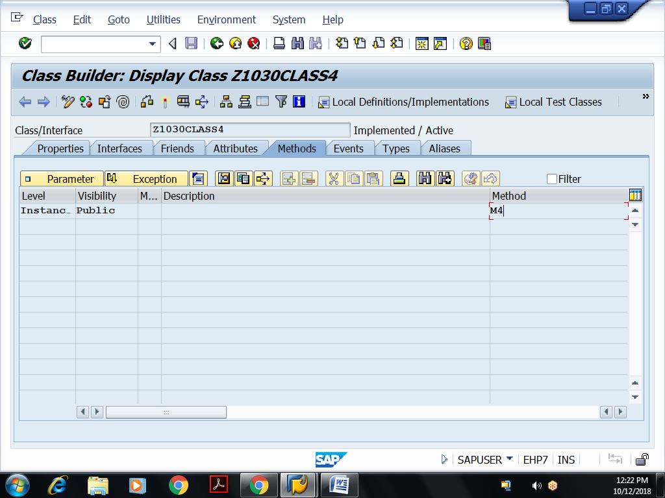
Implementation of Method:
method M4.
write :/ 'Inside Instance public method m4 of class 4...'.
data k type ref to z1030class3.
create object k.
call method k->m1.
call method k->m2.
call method k->m3.
endmethod.
Executable Program:
REPORT Z1030OOPS10.
data ob type ref to z1030class4.
create object ob.
call method ob->m4.

